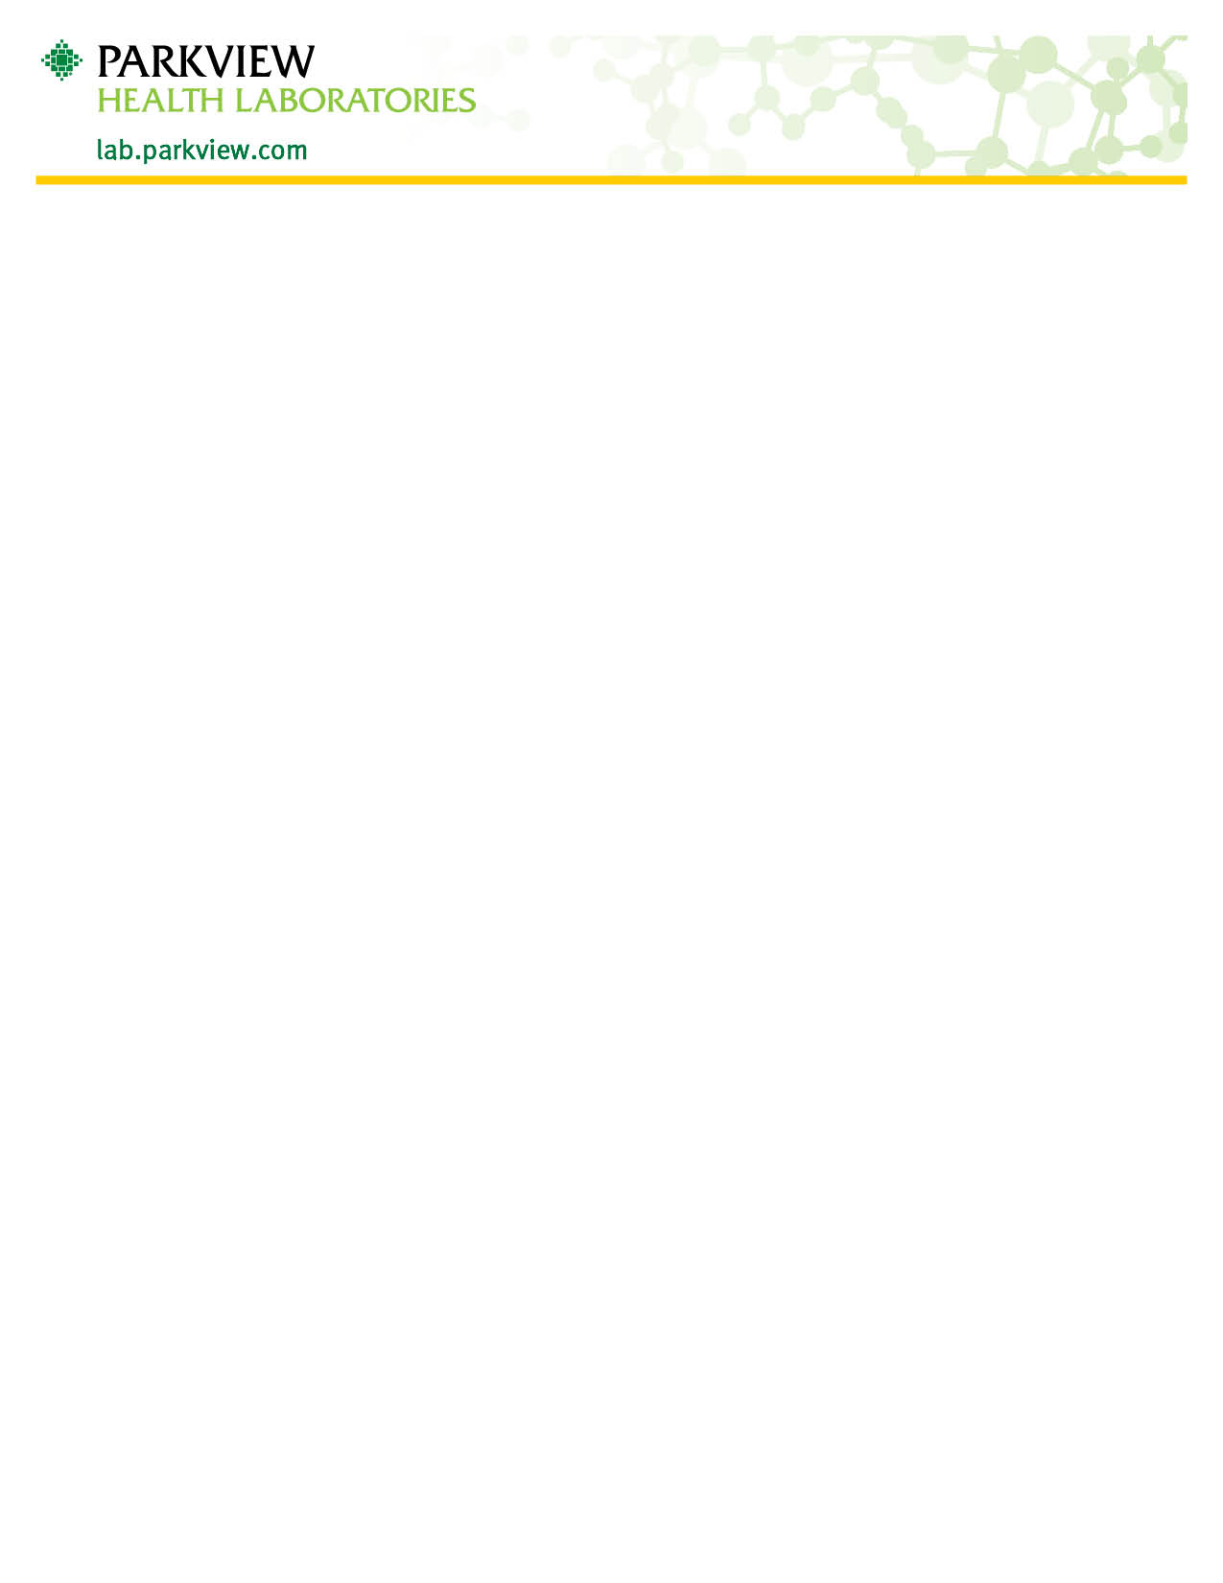

Expectorated Sputum Collection
Collect the specimen first thing in the morning before breakfast; this is to acquire an overnight accumulation of secretions.
- Rinse mouth with water before collection, to reduce contamination.
  - Do not use mouthwash or toothpaste before collection.
- Cough up deeply from the chest into the container provided.
  - Do not just “spit” saliva from the mouth.
- Try to obtain at least 5.0 to 10.0 ml (1 to 2 teaspoons) of sputum if possible
- Screw the cap back on the container tightly, if necessary clean the exterior of the container.
- Deliver to a Parkview Health Laboratories facility as soon as possible.
  - This specimen is only stable for 2 hours if left at room temperature.
  - If unable to deliver to the lab within 2 hrs. refrigerate, and return to the lab the same day as collected.

